EXP. NO. 1

WEB PAGE CREATION USING HTML

AIM:

To create a simple Online Feedback Collection System with form validation using HTML and JavaScript.

ALGORITHM:

Create the HTML structure:
- Set up the basic HTML document with <!DOCTYPE html>, <html>, <head>, and
<body> tags.
- In the <head>, link the external CSS file (<link> tag), define the title, and include any metadata.
- In the <body>, create the necessary elements:
  - Frames: Use the <frameset> tag to create a frame layout (for older browsers, use <iframe> instead).
  - Map: Use the <img> tag to display a map.
  - Hotspots: Create clickable regions using the <map> and <area> tags.
  - Links: Add hyperlinks (<a>) to navigate to different parts of the page or external sites.

Create CSS Styles:
- External CSS: In a separate file, define styles such as colors, fonts, and layout for the entire page.
- Inline CSS: Use the style attribute within specific tags to apply styles (e.g., in <div> or <p> tags).
- Embedded CSS: Inside the <style> tag in the <head>, define styles for specific elements like the map, frames, and text.

Map with Hotspots:
- Use the <map> tag to create an image map.
Define the <area> tag for each hotspot, specifying the coordinates (e.g., coords="x,y,x2,y2") for clickable areas on the map
FRAMES:
- Use the <iframe> tag for embedding external content like a map or another webpage, with attributes such as src for the URL, width, and height.

Add Links:
- Inside the <body>, use the <a> tag to create links for navigation (for example, to link to specific parts of the page or external sites).

Test the Page:
- Test the webpage to check the functionality of frames, hotspots, and links. Ensure that the map hotspots are clickable and the linked content displays correctly.
- Ensure that the styles are applied properly using inline, embedded, and external CSS.
CODE:
index.html :

<!DOCTYPE html>
<html>
<head>
<title>Online Feedback Collection System</title>

<style>
body{
font-family: Arial;
background-color: lightgray;
text-align: center;
}

.box{
background-color: white;
width: 350px;
margin: auto;
padding: 20px;
border-radius: 10px;
}

input, textarea{
width: 90%;
padding: 8px;
margin: 5px;
}

button{
background-color: blue;
color: white;
padding: 10px;
border: none;
}
</style>

</head>

<body>

<h1>Online Feedback Collection System</h1>

<div class="box">

<form>

<input type="text" placeholder="Enter Name"><br>

<input type="email" placeholder="Enter Email"><br>

<textarea rows="4" placeholder="Enter Feedback"></textarea><br>

<button>Submit</button>

</form>

</div>

<br>

<h2>Location Map</h2>

<iframe
src="https://www.google.com/maps/embed?pb="
width="400"
height="250">
</iframe>

<br><br>

<a href="https://www.google.com">Visit Google</a>

</body>
</html>

OUTPUT:
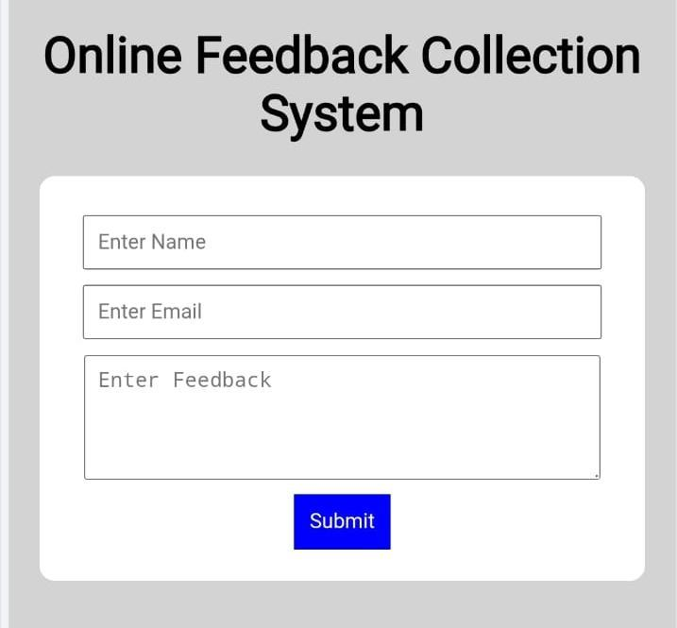

RESULT:
The Online Feedback Collection System page is created successfully using HTML and JavaScript.

